The VM Customization specification is good when you’re deploying a new vm from template you can use a custom options to configure your vm.

VM customization specification can be used - to sysprep the machine Generate a new security identity (SID) , vm name options, domain, timezone, use a sysprep file, owner info, product key, admin password, commands to run when user logs on, nic options. The below is a walk through

In your vm click the three lines > click policies and profiles

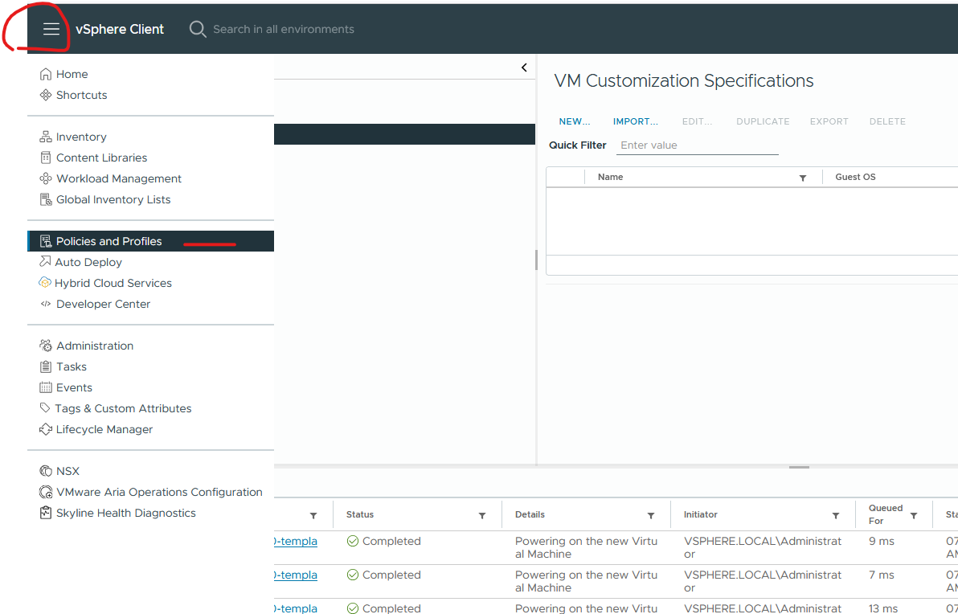

Select vm customization specifications > click new

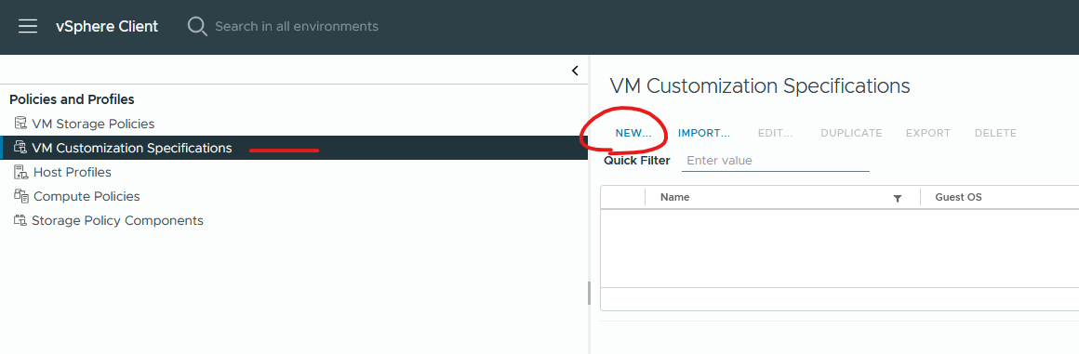

Give it a name > select windows > select generate a new security identity (sid) > click next

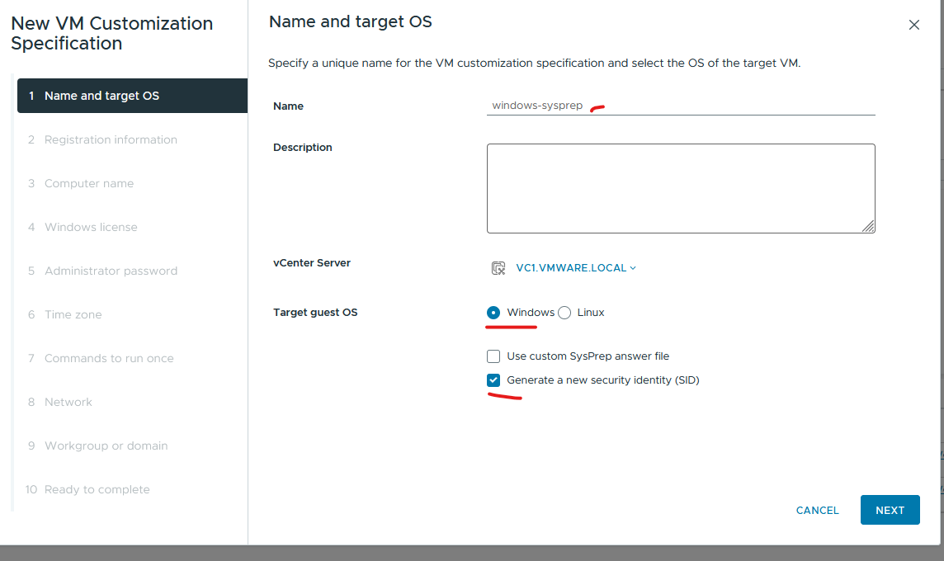

Type in owner info > click next

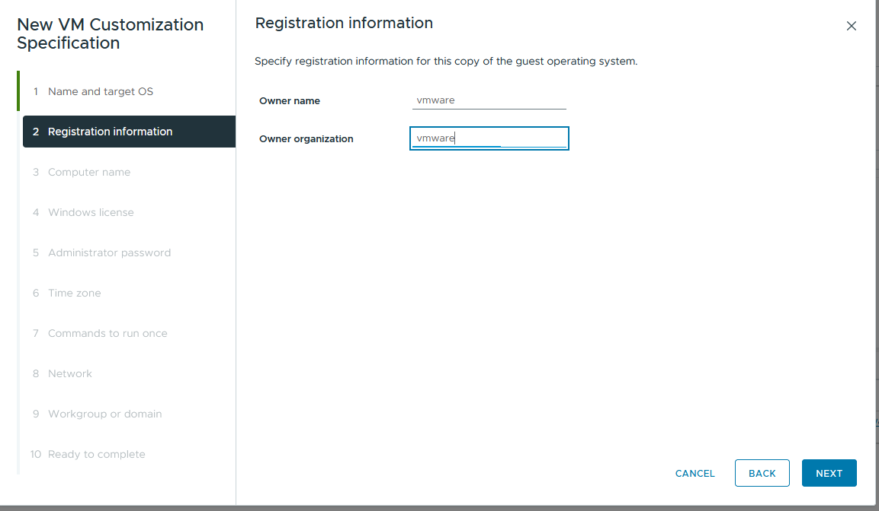

Select use the virtual machine name > click next

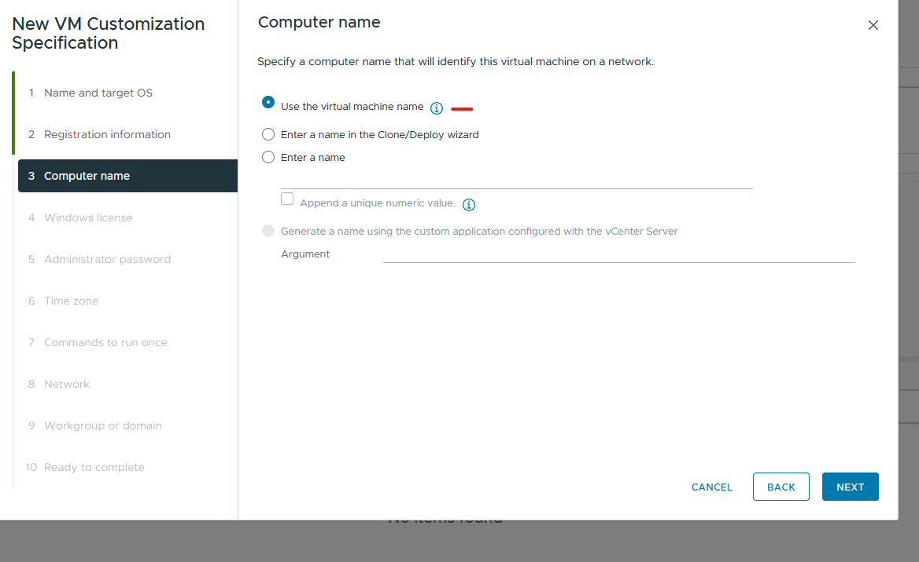

Type in product key info > click next

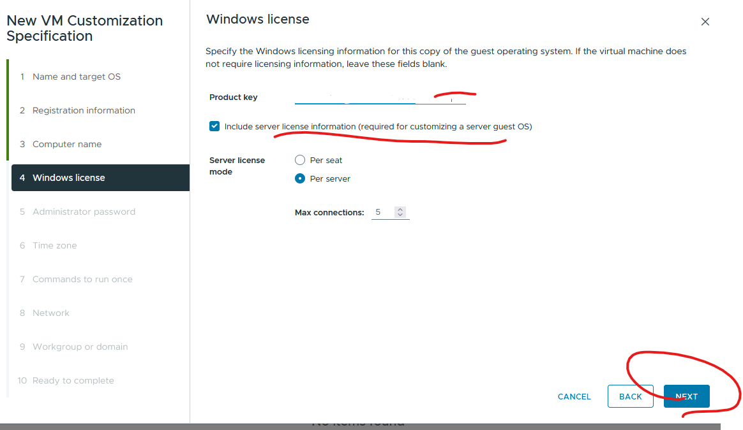

Type in admin password > click automatically logon as admin ‘once’ > click next

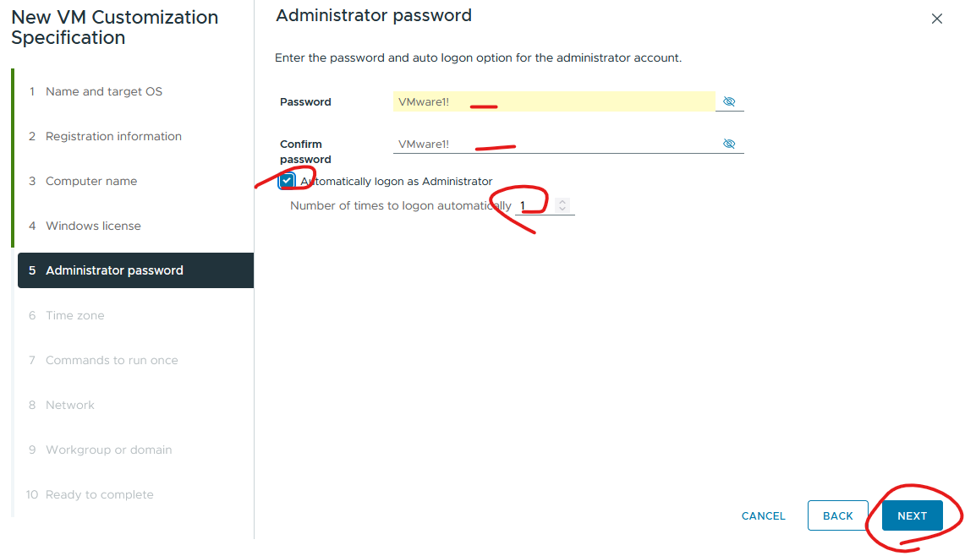

Select time zone > click next

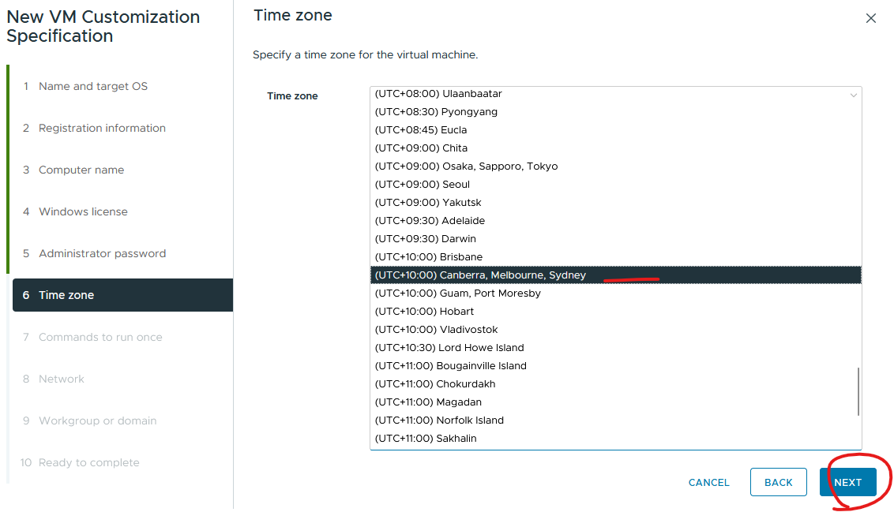

Enter your commands > click add > click next (for example C:\Windows\System32\cmd.exe /c mkdir C:\Temp\test)

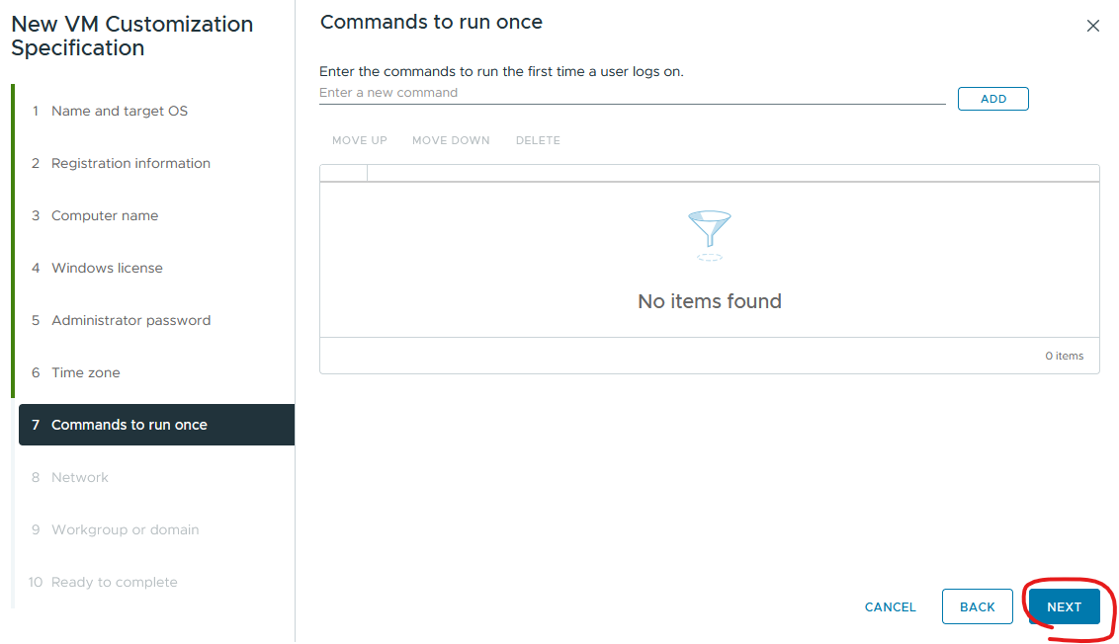

Select your nic options and click next –

Using dhcp

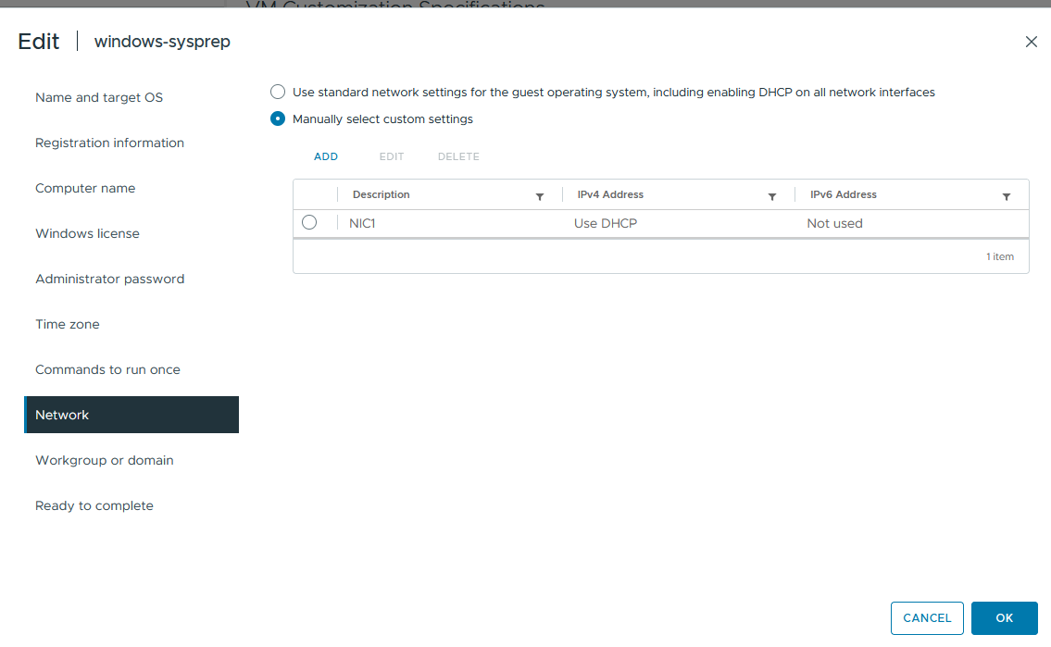

Using static

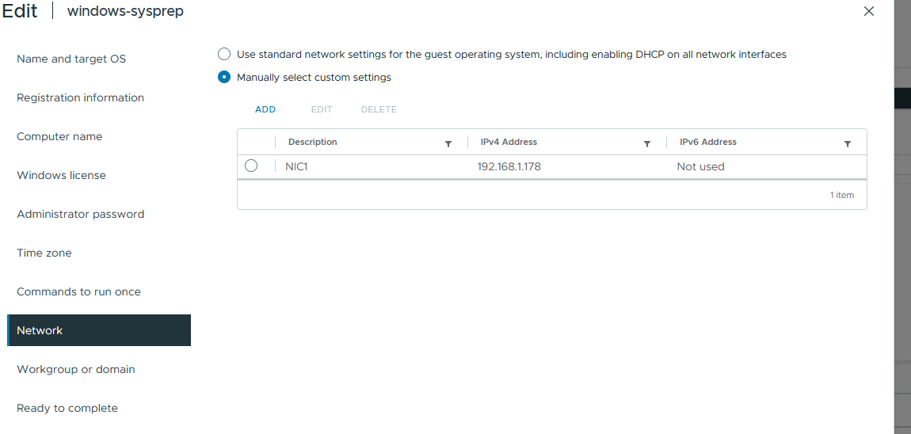

Type in domain info > join account info > ou path > click next

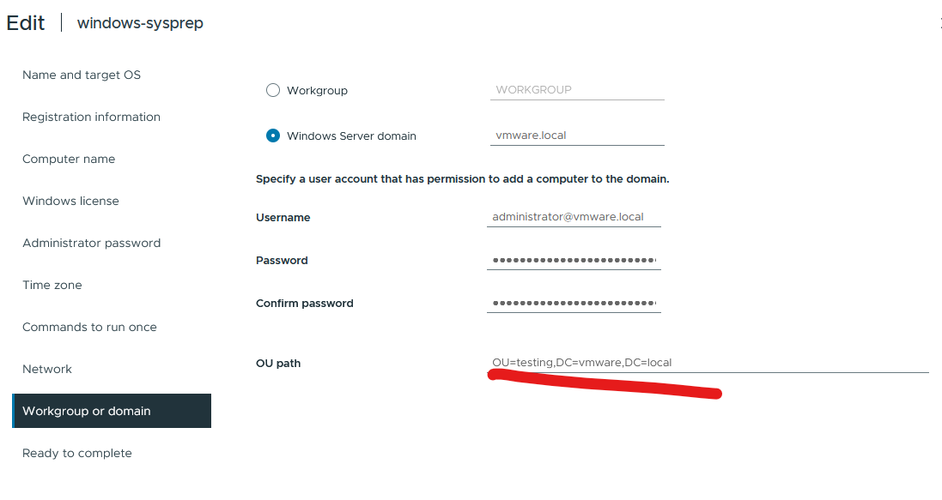

Click finish

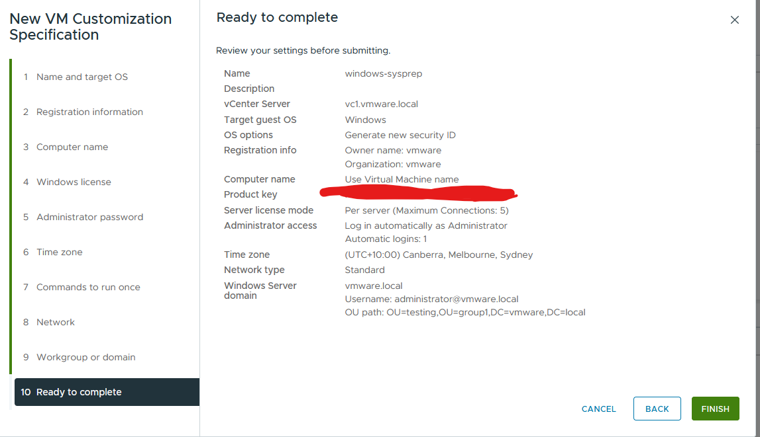

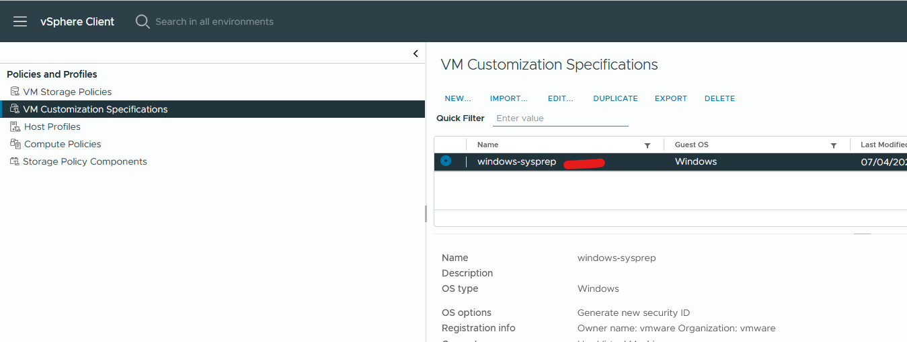

Now test it > right click template > new vm from this template

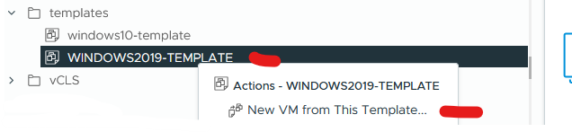

Type in server name > click next

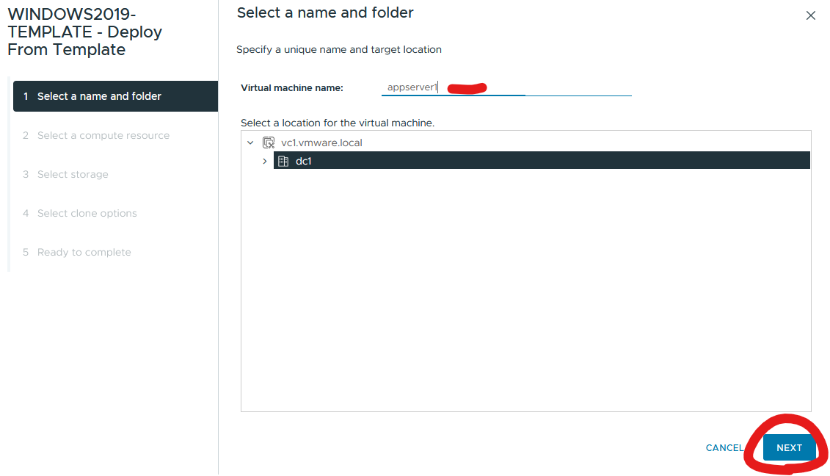

Select resource > click next

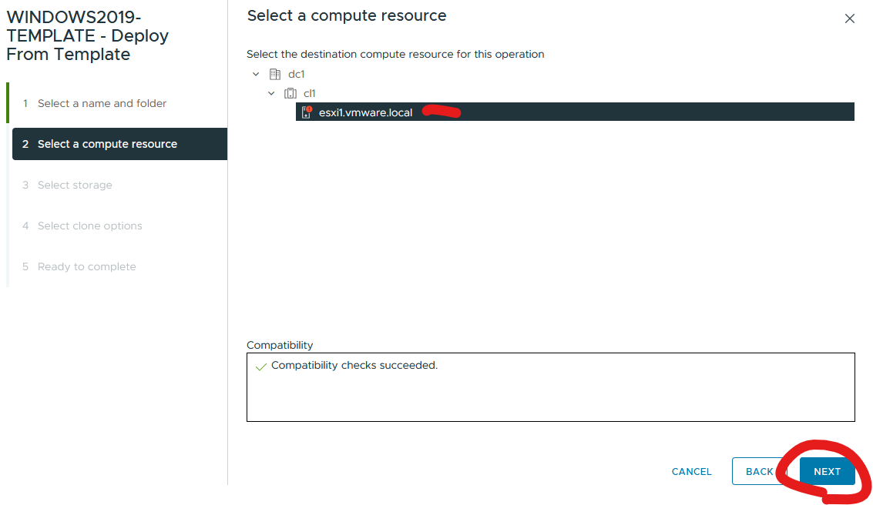

Select storage > click next

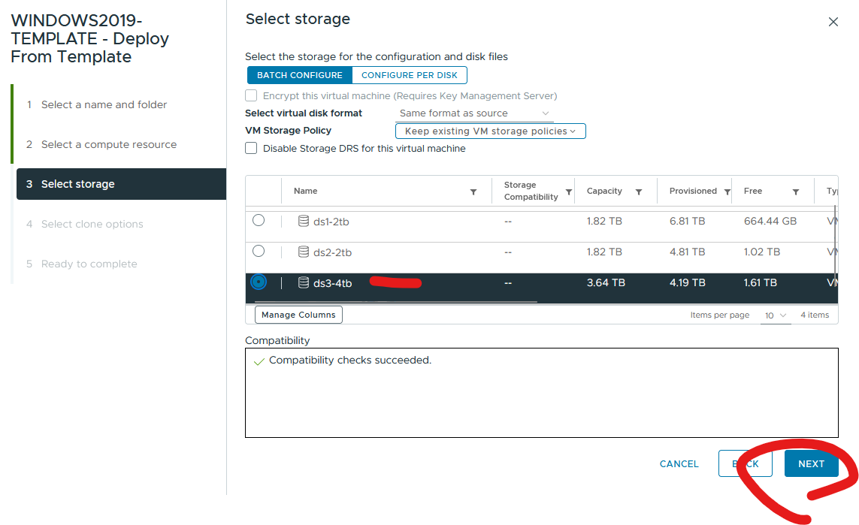

Select customize the operating system > select power on virtual machine after creation > click next

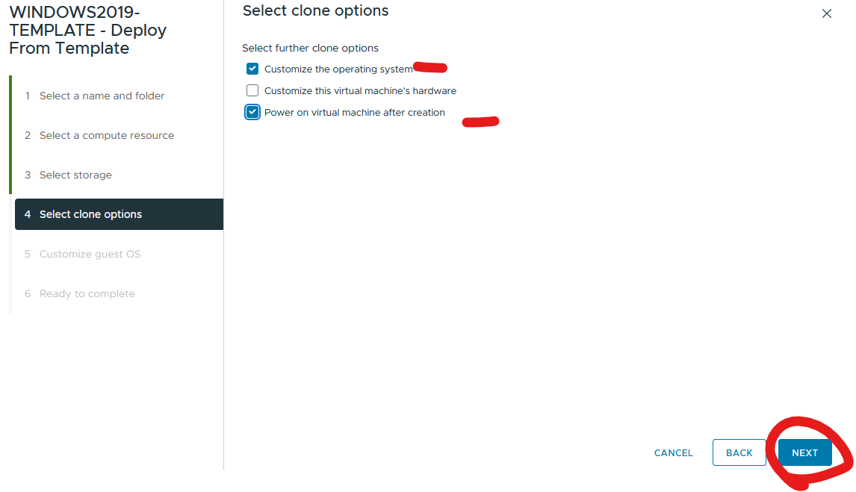

Select vm customization spec > click next

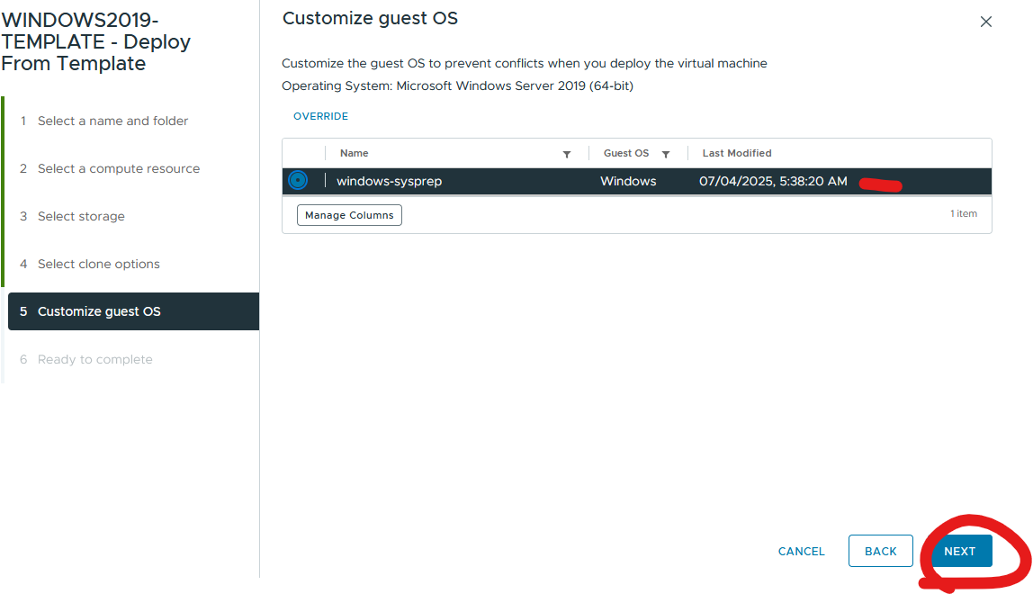

Click finish

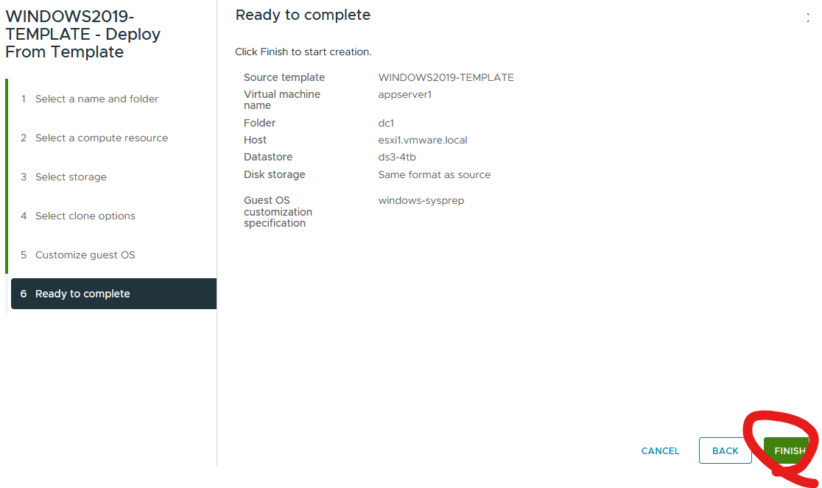

Joined to domain and has a IP address

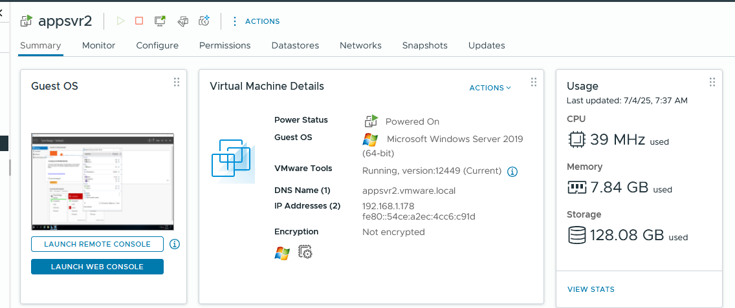

Moved to the correct OU in AD

